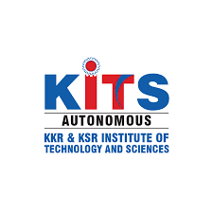

KKR & KSR Institute of Technology and Sciences
(Autonomous)
Approved by AICTE, New Delhi and Permanently Affiliated to JNTUK, Kakinada
Accredited by NBA-Tier-I(WA) & NAAC with Grade ‘A’.

DEPARTMENT OF CSE (AI & ML)

CODECHEF
(A CODING COMPETITION)

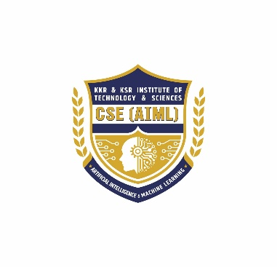
Date : 06.01.2026 Venue: Sir C.V.Raman Hall

Organized by
KITS ACM STUDENT CHAPTER

Name of the Event : CODECHEF-A CODING COMPETITION
Name of the Chief Guest : Mr.Yugandhar Suryadevara
Director-Sales & Marketing,
Pivox Labs (A Software Development Company),
Guntur.
Organised by : KITS ACM Student Chapter, Department of
CSE(AIML)
Host Institution : KKR & KSR Institute of Technology and Sciences –
(AUTONOMOUS)
Number of ACM Student Members attended: 18

Number of Professional Members attended: 3
Number of students attended : 350
On January 6, 2026, the KITS ACM Student Chapter (Department of CSE – (AI & ML) successfully organised a coding competition-CODECHEF for our college students. This competition was conducted at two different levels. Level-I consists of 30 MCQ questions which are of industry standard for 30 minutes duration. The Level II consists of problem-solving and coding questions that are tricky and difficult. A total of 151 students participated in the competition. To determine the winners, an online LMS platform was used. A cash award of Rs.7000/- was given to the first prize winners and two teams were given a cash award of Rs.4000/- each for the second place. Mr.Yugandhar Suryadevara, Director-Sales & Marketing, Pivox Labs (A Software Development Company),Guntur has distributed the prizes.

A separate booth was also arranged to promote ACM memberships and the benefits of this internationally renowned professional society to the engineering students.

Objectives:
- To enhance problem-solving skills among students by encouraging logical thinking and algorithmic approaches to real-world problems.
- To promote the practical application of programming concepts learned in the classroom through hands-on coding challenges.
- To foster interest in competitive programming and software development, motivating students to explore advanced coding platforms and technologies.
- To improve coding proficiency in popular programming languages such as C, C++, Java, Python, and others relevant to industry standards.
- To encourage innovation and creativity by allowing students to develop efficient and optimised solutions under time constraints.
- To identify and nurture talented programmers who demonstrate strong analytical and coding abilities.
- To develop teamwork and collaboration skills through collective problem-solving and peer learning.
- To familiarise students with industry-style coding environments, including online judges, debugging practices, and version control concepts.
- To build confidence and competitive spirit among students while promoting ethical coding practices and fair competition.
- To bridge the gap between academic learning and industry expectations by aligning problem statements with real-world and interview-oriented challenges.

Programme schedule:
08:00 AM – 08:30 AM : Instructions & Seating Arrangements
08:30 AM – 09:45 AM : Level–1 Competition – Batch–1 (2nd Year Students)
09:45 AM – 10:00 AM : Seminar Hall Gathering
10:00 AM – 10:30 AM : Arrangements & Instructions for Batch–2
10:30 AM – 11:45 AM : Level–1 Competition – Batch–2 (3rd Year Students)
11:45 AM – 12:00 PM : Gathering & Coordination
12:00 PM – 01:00 PM : Evaluation of Level–1
01:00 PM – 02:00 PM : Lunch Break (Batch–2)
02:00 PM – 02:30 PM : Level–2 Gathering & Explanation
02:30 PM – 04:00 PM : Level–2 Examination
04:00 PM – 04:30 PM : Snacks & Certificate Distribution
04:30 PM – 05:00 PM : Valediction & Prize Distribution

Target audience:
Undergraduate students of CSE-(AI & ML) and allied branches, faculty members, research scholars.
- Opportunities in AI-security research, secure MLOps, incident response for AI systems, and policy/ethics roles.
- Recommended starting projects and learning resources (practical labs, datasets, conferences).

Outcomes of the Programme:
After participating in the coding competition, students were able to:
- Apply programming fundamentals effectively to solve computational and real-world problems within a limited time frame.
- Demonstrate improved problem-solving and analytical thinking skills through algorithmic and logical reasoning.
- Develop efficient and optimised code, adhering to best practices in coding standards and debugging techniques.
- Gain exposure to competitive programming environments, including online judges, test case evaluation, and performance-based scoring.
- Enhance confidence in coding and technical interviews, particularly in data structures, algorithms, and logical problem-solving.
- Exhibit improved time management and decision-making skills while working under competitive conditions.
- Strengthen teamwork and communication skills since the event is team-based through collaborative problem-solving and idea sharing.
- Identify individual strengths and areas for improvement in programming and algorithm design.
- Increase readiness for industry and higher studies, aligning technical skills with current industry and research expectations.
- Develop a positive attitude toward continuous learning and innovation in the field of computer science and emerging technologies.

PHOTOS:
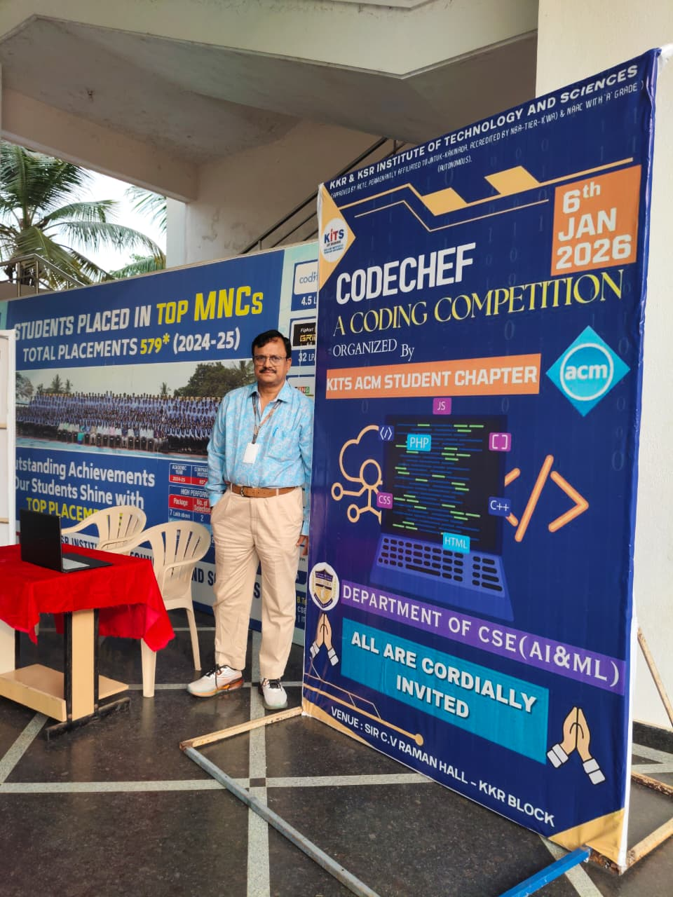 | 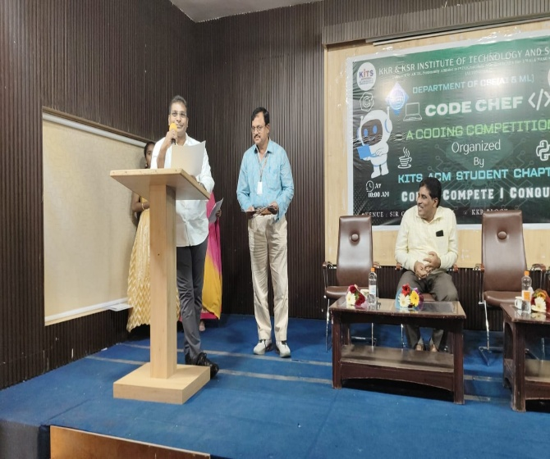
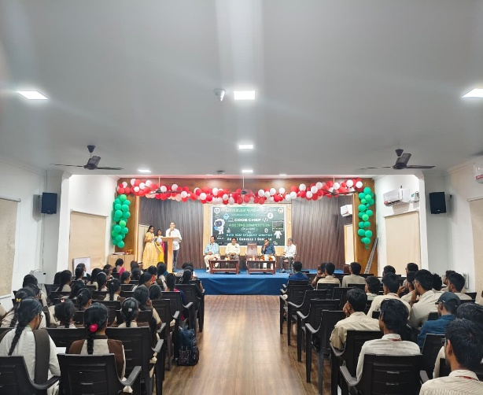 | 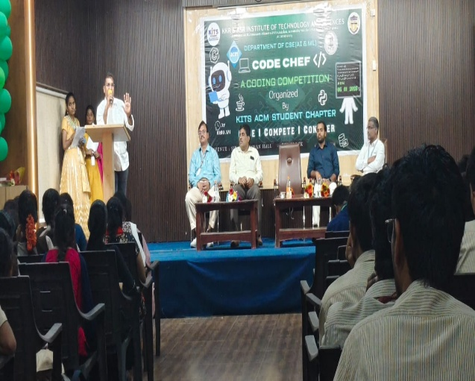
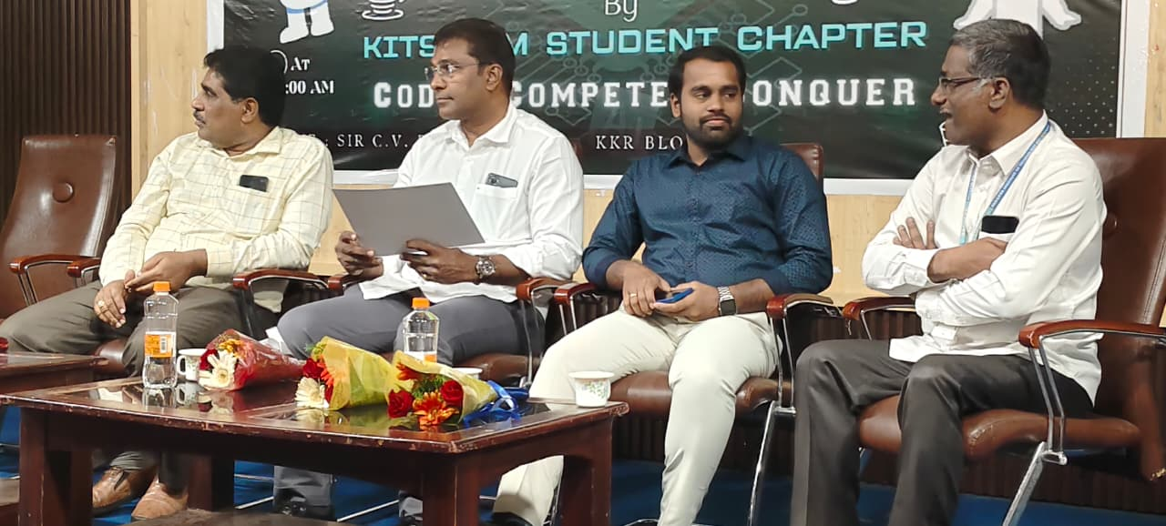 | 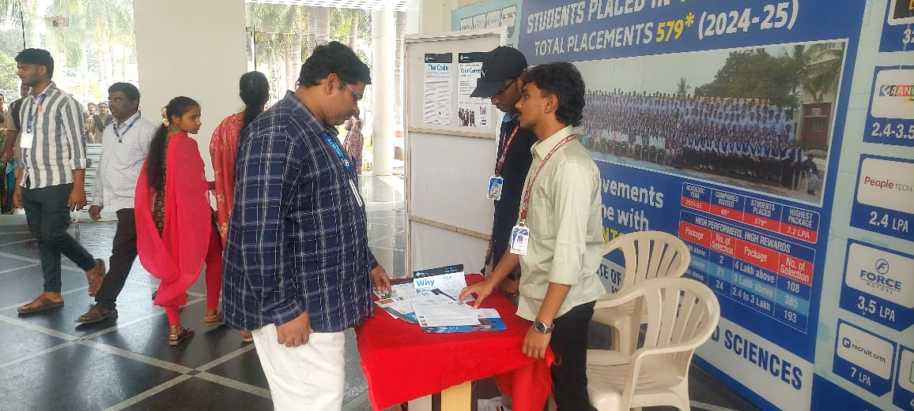
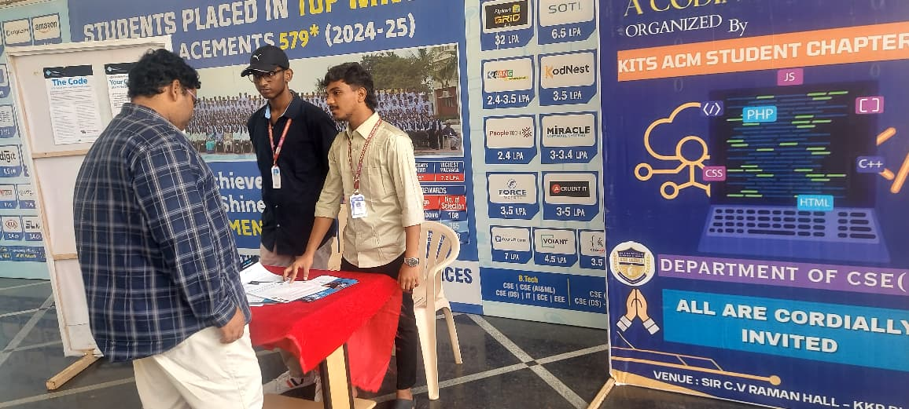 | 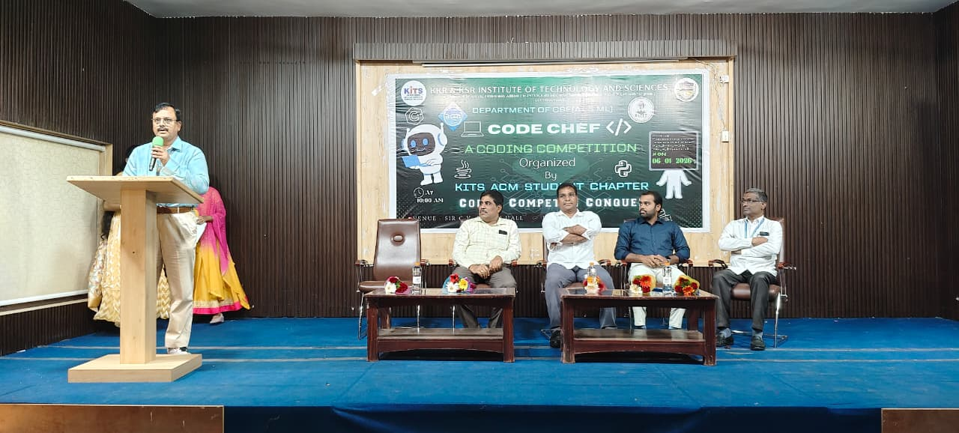
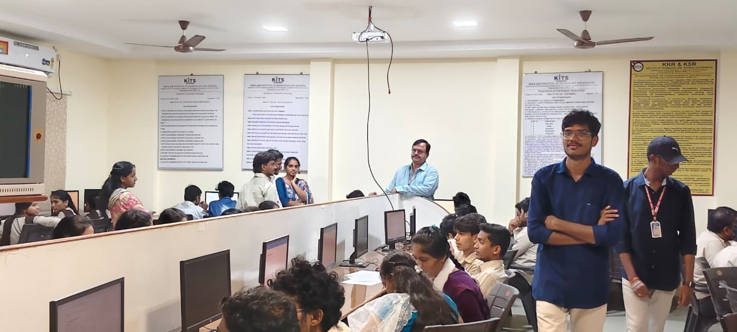 | 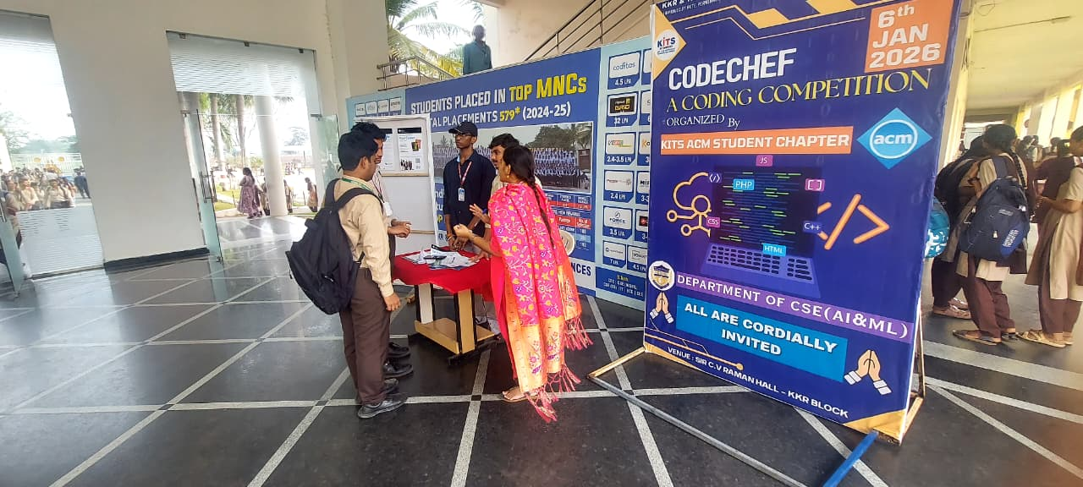
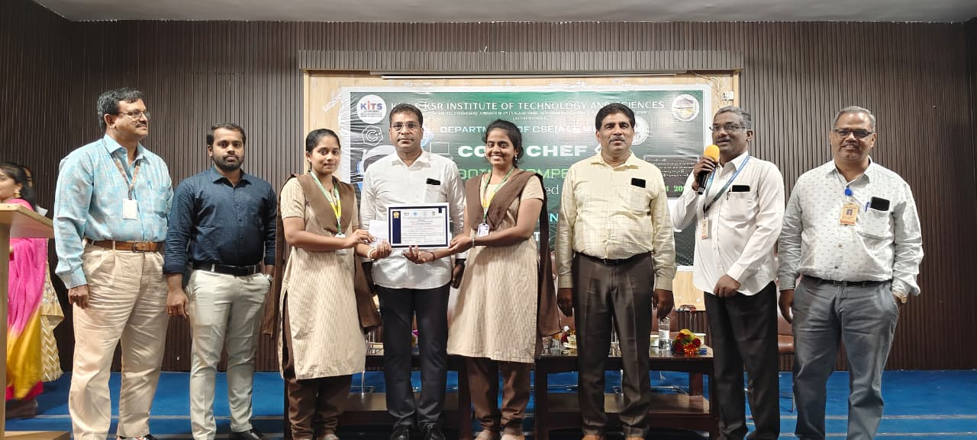 | 